附件1

2024年第一届陕西省大学生花艺大赛报名表

|  |  |  |  |  |  |  |  |  |  |  |  |  |  |  |  |  |  |  |  |  |  |  |  |  |  |  |  |  |
| --- | --- | --- | --- | --- | --- | --- | --- | --- | --- | --- | --- | --- | --- | --- | --- | --- | --- | --- | --- | --- | --- | --- | --- | --- | --- | --- | --- | --- |
| 院校名称： | | | | | | | | | | | | | | | | | | | | | | | | | | | | |
| 参赛项目类别：□插花艺术 □盆景艺术 □压花画类 □立体干花类 □组合盆栽 | | | | | | | | | | | | | | | | | | | | | | | | | | | | |
| 姓名： | | | | | | 性别： □男 □女 | | | | | | | | | | | | | | 民族： | | | | | | | | |
| 学号： | | | | | | | | | | | 手机： | | | | | | | | | | | | | | | | | |
| 专业： | | | | | | | | | | | 年级、班级： | | | | | | | | | | | | | | | | | |
| 身份证号： |  | |  |  |  | | |  |  |  | | |  | |  |  |  | |  | |  |  | |  | |  |  |  |
| 队员1 | 姓名 | |  | | | | 队员2 | | | | | 姓名 | |  | | | | 队员3 | | | | | 姓名 | |  | | | |
| 学号 | |  | | | | 学号 | |  | | | | 学号 | |  | | | |
| 指导教师姓名： | | | | | | | | | | | | | 指导教师手机： | | | | | | | |  | | | | | | | |
| 教师身份证号 |  | |  |  |  | | |  |  |  | | |  | |  |  |  | |  | |  |  | |  | |  |  |  |
| 教学主管部门推荐意见：  盖 章  年 月 日 | | | | | | | | | | | | | | | | | | | | | | | | | | | | |
| 备注 | |  | | | | | | | | | | | | | | | | | | | | | | | | | | |

**参赛作品报送表**

请在此处添加设计方案图纸或照片

**作品名称：**

**作品类型：**

**作品尺寸：**

**主要花材：**

**作品说明（限200字以内）：**

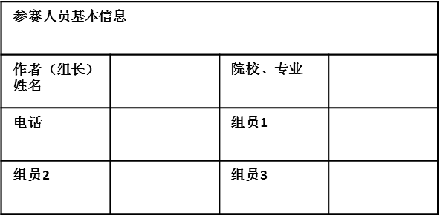

|  |  |  |  |
| --- | --- | --- | --- |
| **参赛人员基本信息** | | | |
| **组长姓名** |  | **院校、专业** |  |
| **电话** |  | **组员1** |  |
| 组员2 |  | 组员3 |  |